A Project Report On  
**Restaurant Website**

Name: More Vishal Sanjay

Type of Project: Web Technology  
 Languages Used :HTML5,CSS3,Bootstrap5

&Javascript

Date of Submission: 26-09-2024

1. **Overview:**

A restaurant website serves as an online platform for showcasing the restaurant's identity, menu, ambience, services, and contact information. It acts as a digital storefront, allowing potential customers to learn about the restaurant, make reservations, and explore offerings. The website should reflect the restaurant's theme and provide a seamless user experience to enhance customer engagement.

1. **Objectives :**

Brand Awareness: Establish a strong online presence to promote the restaurant's brand and attract new customers.

**Customer Engagement:** Foster a connection with customers through interactive features, such as newsletters, social media integration, and customer reviews.

**Menu Display:** Provide an easily accessible and visually appealing menu that showcases the restaurant's offerings, including descriptions and prices.

**Reservation Management:** Enable customers to make reservations online, reducing wait times and improving customer satisfaction.

**Event Promotion:** Highlight special events, promotions, and seasonal offerings to encourage repeat visits.

**Information Hub:** Serves as a central source of information about the restaurant, including location, hours of operation, contact details, and FAQs.

1. **Key Features** :

**Responsive Design**: Ensure the website is mobile-friendly and adapts to various screen sizes for optimal user experience.

**Menu Section:** An interactive menu that includes categories (appetizers, mains, desserts, beverages), descriptions, prices, and high-quality images of dishes. –

**Online Reservations**: A user-friendly reservation system that allows customers to select dates, times, and party sizes, with confirmation notifications.

**Contact Information**: Clear contact details, including phone number, email, and location with an embedded Google Maps link for easy navigation.

**About Us Page**: A section that tells the story of the restaurant, its mission, values, and the team behind it.

**Social Media Integration**: Links to the restaurant's social media profiles and feeds to encourage community interaction.

**Newsletter Signup:** An option for customers to subscribe to newsletters for updates, promotions, and special offers.

**Accessibility Features**: Ensure the website is accessible to all users, including those with disabilities.

**4.Output Screens:**

Home Page

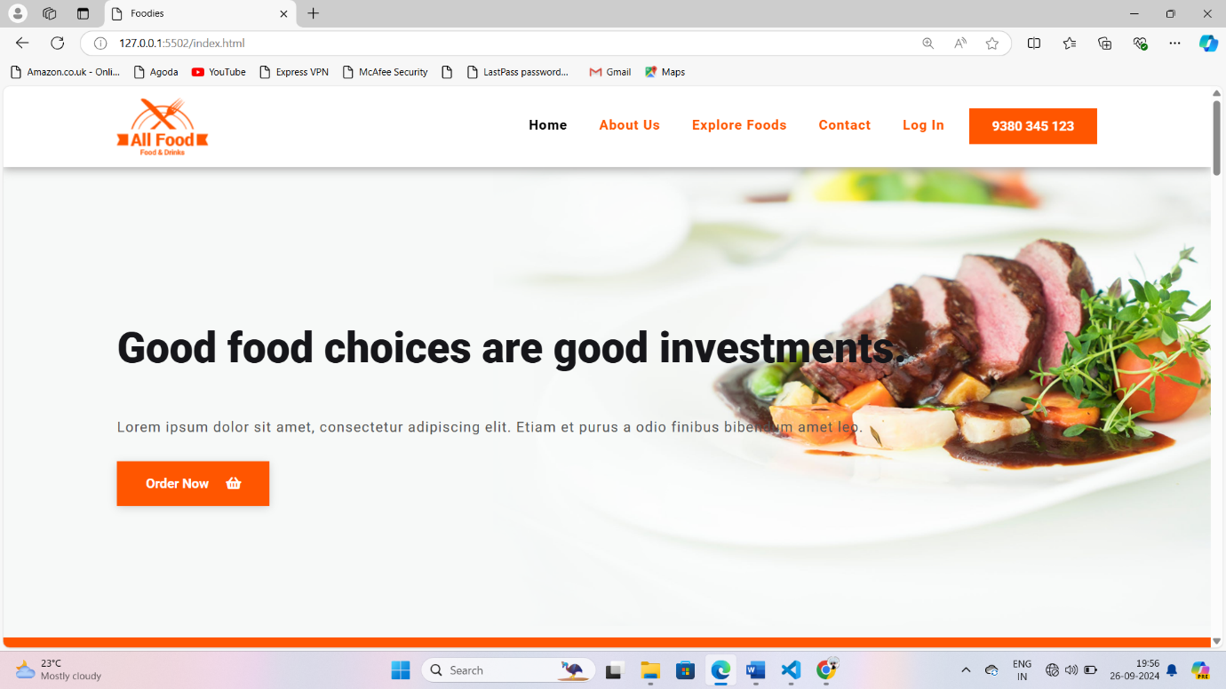

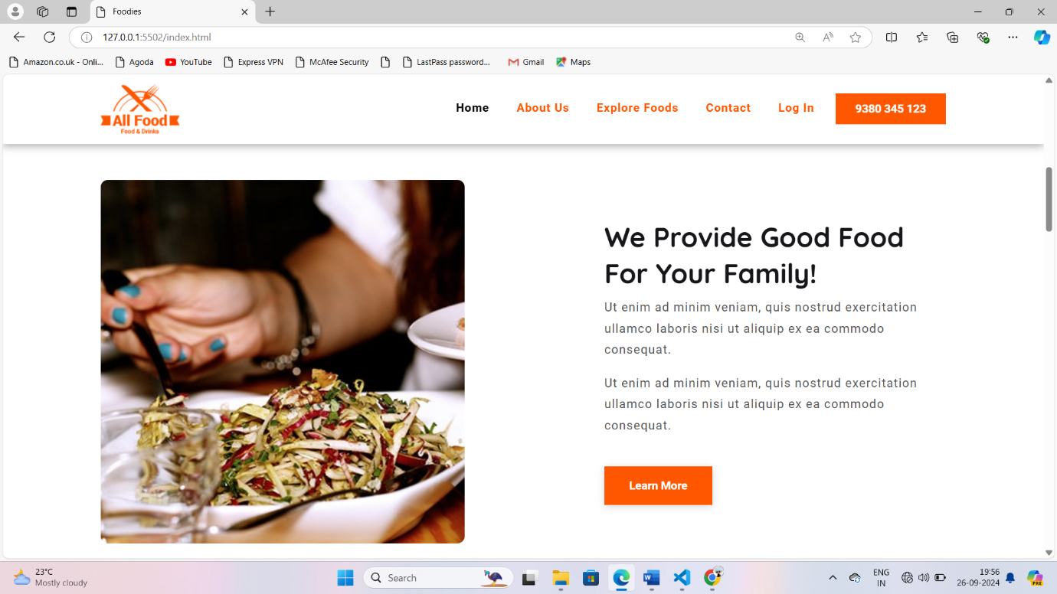

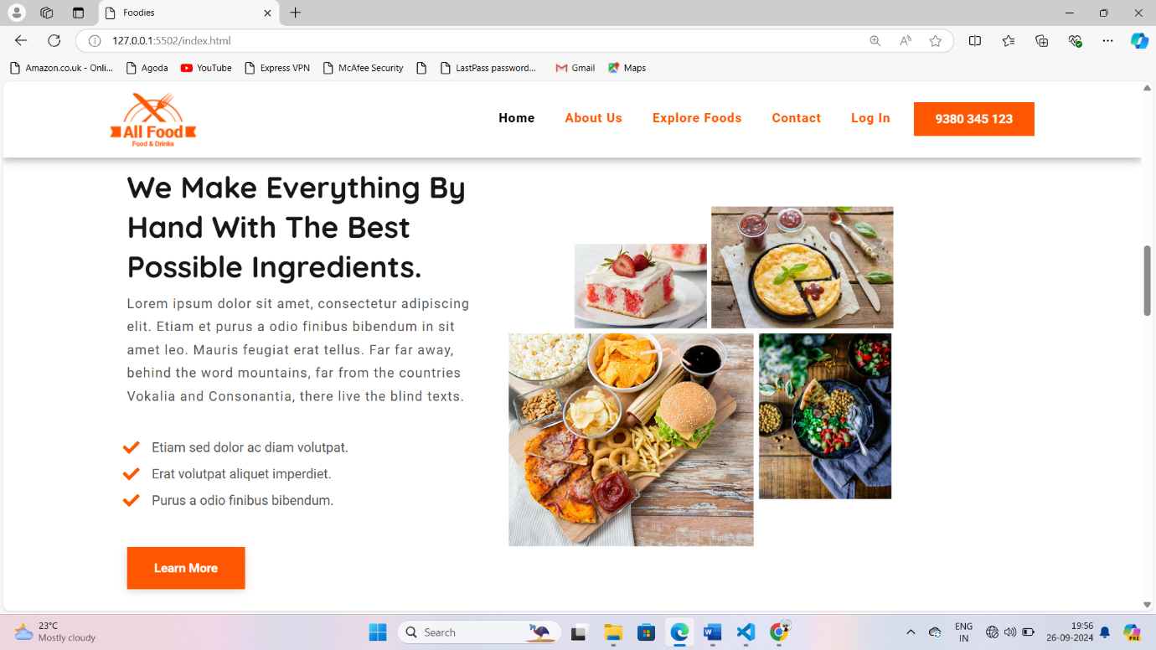

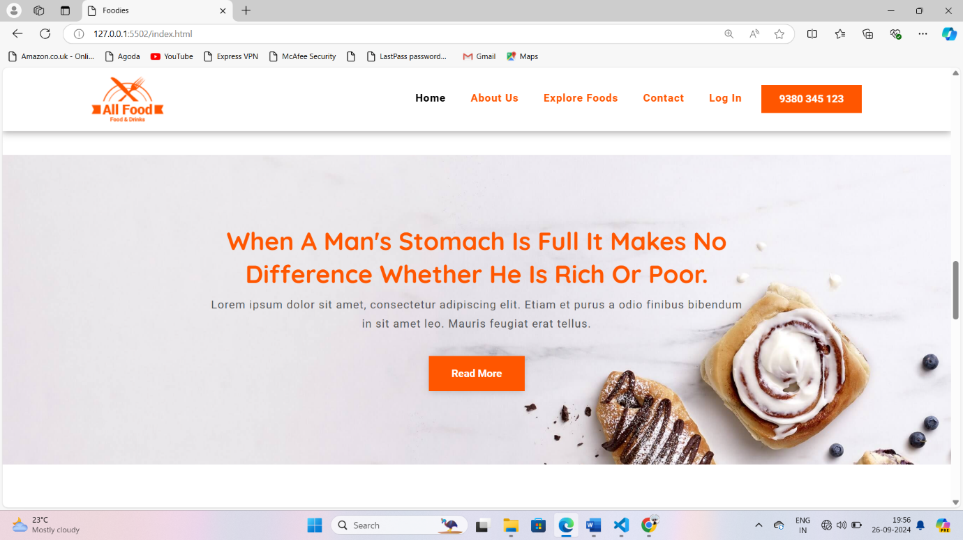

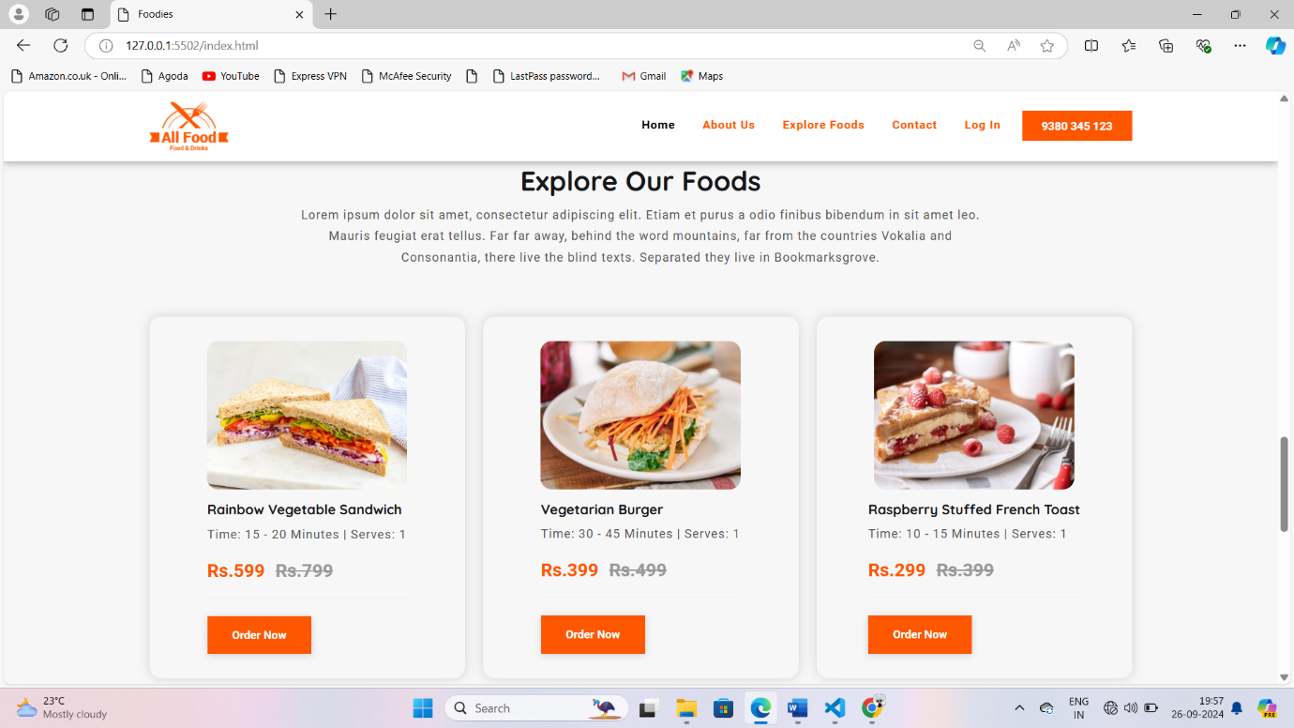

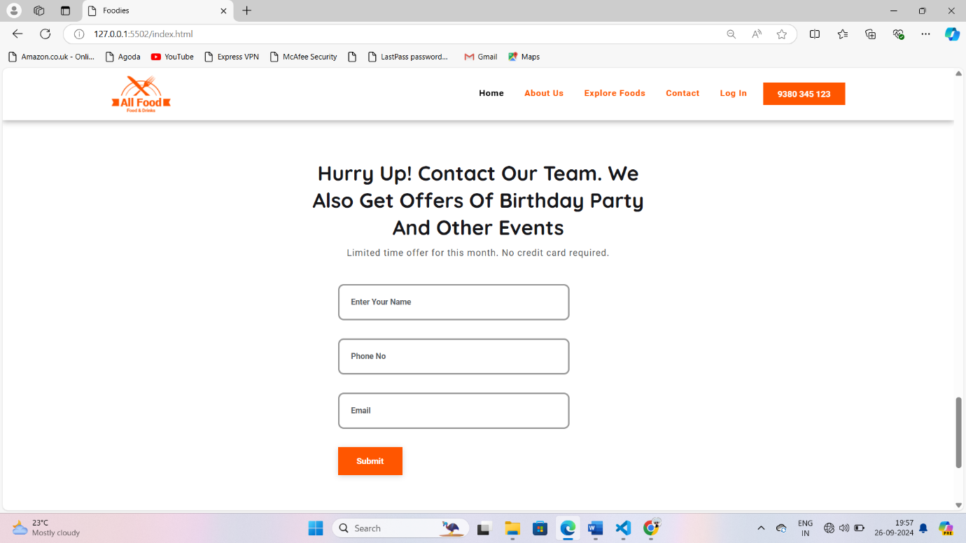



About us

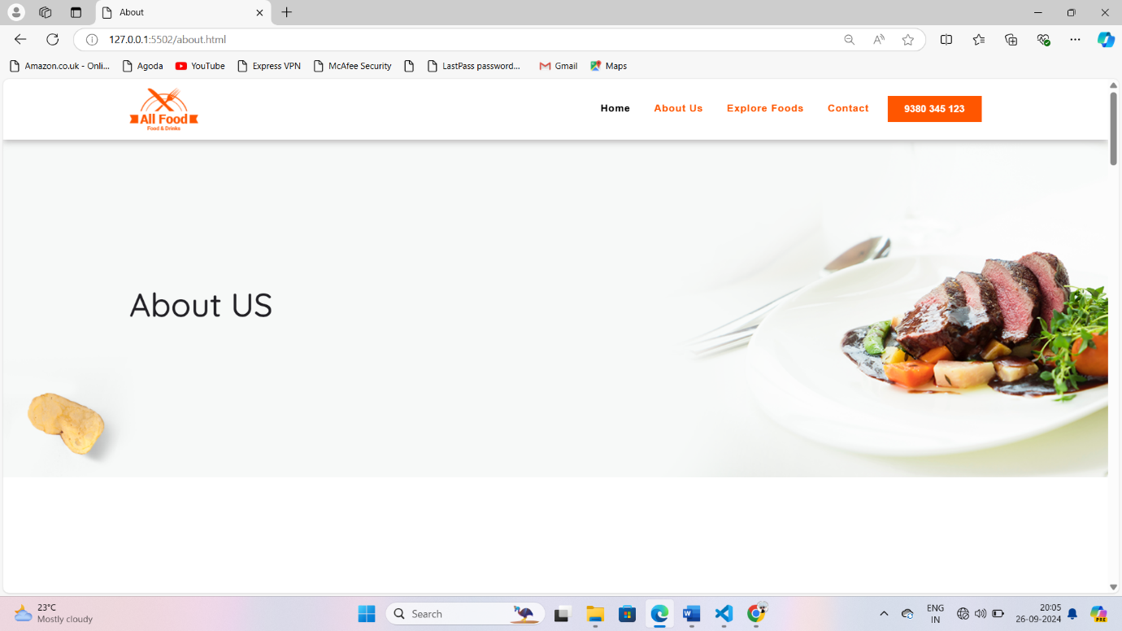

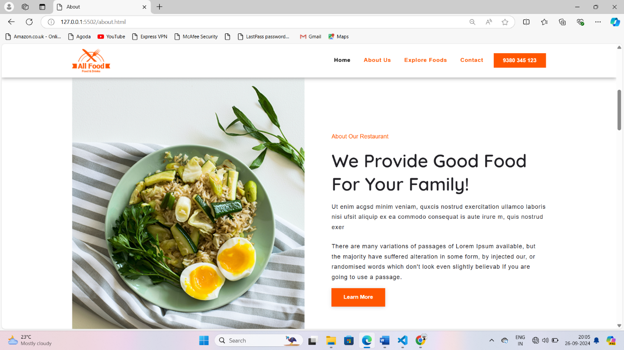

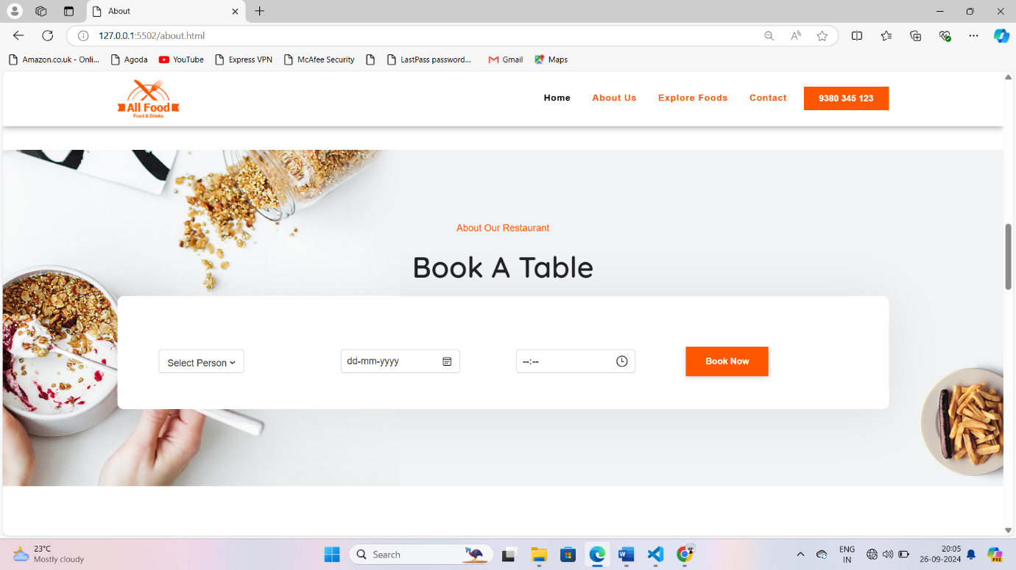

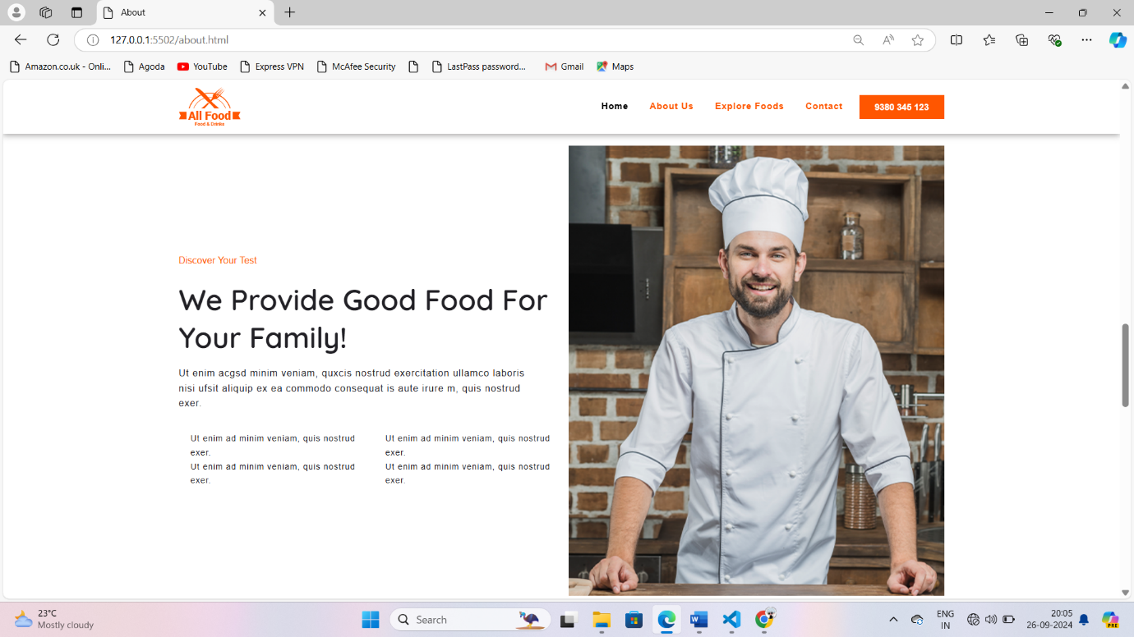

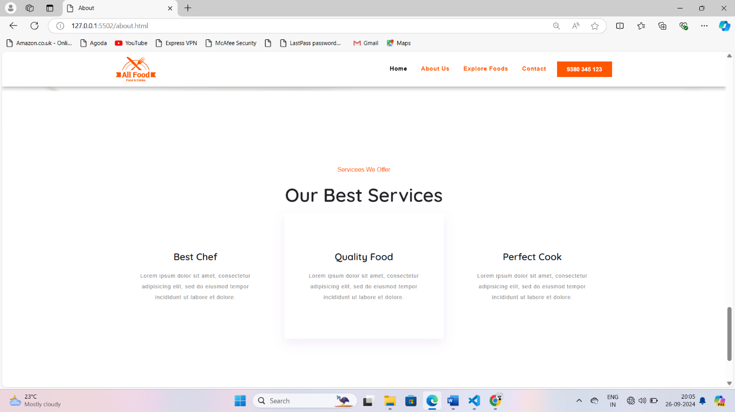



Explore-Food

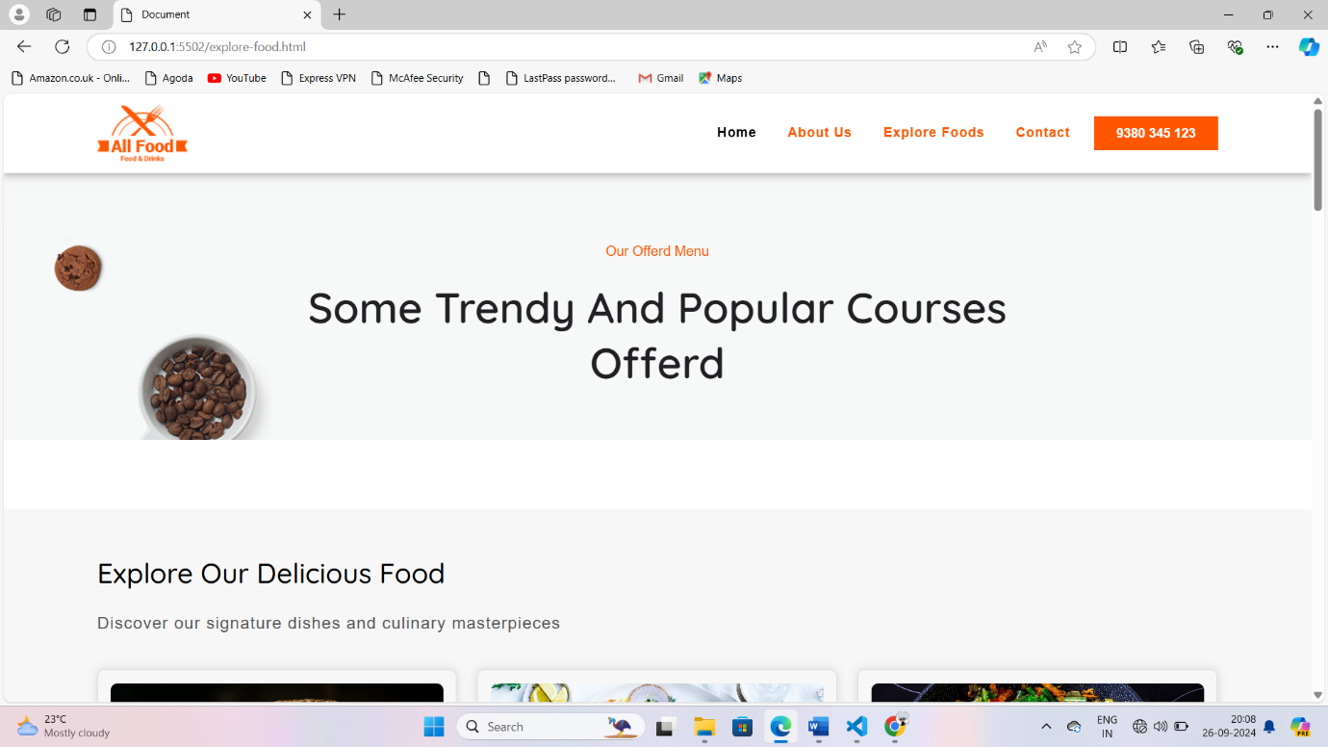

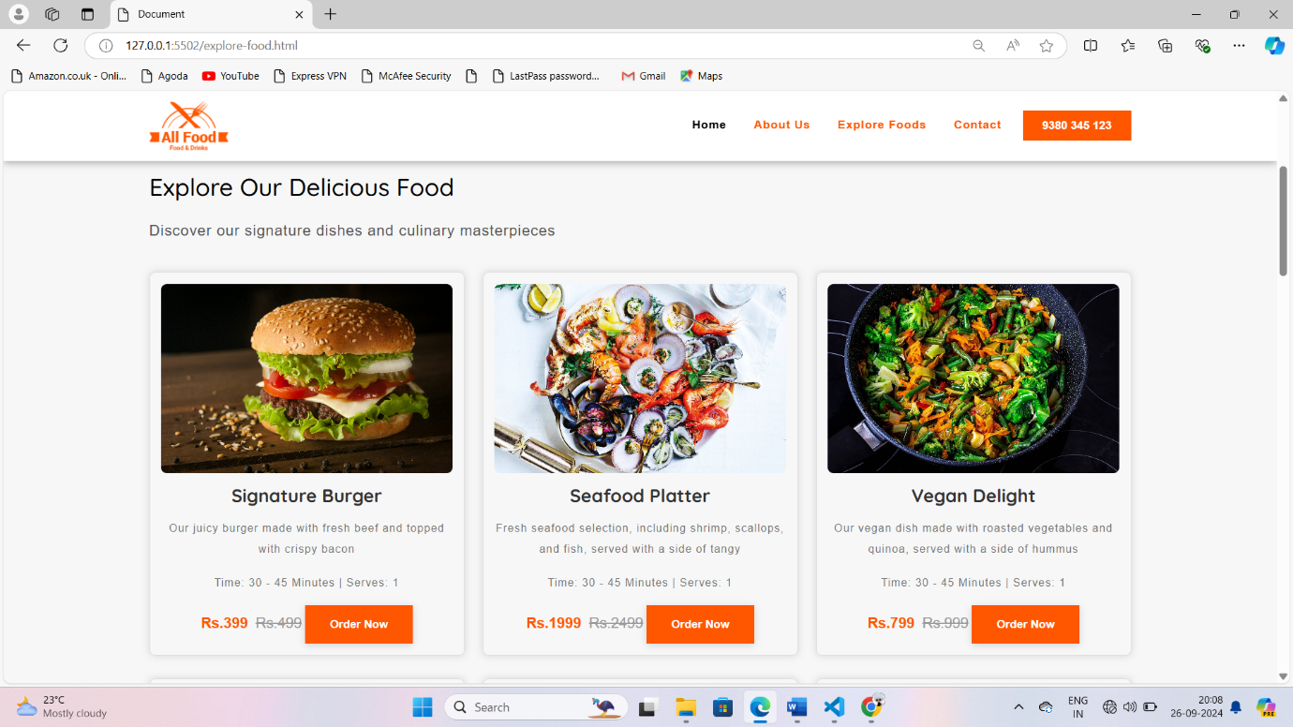

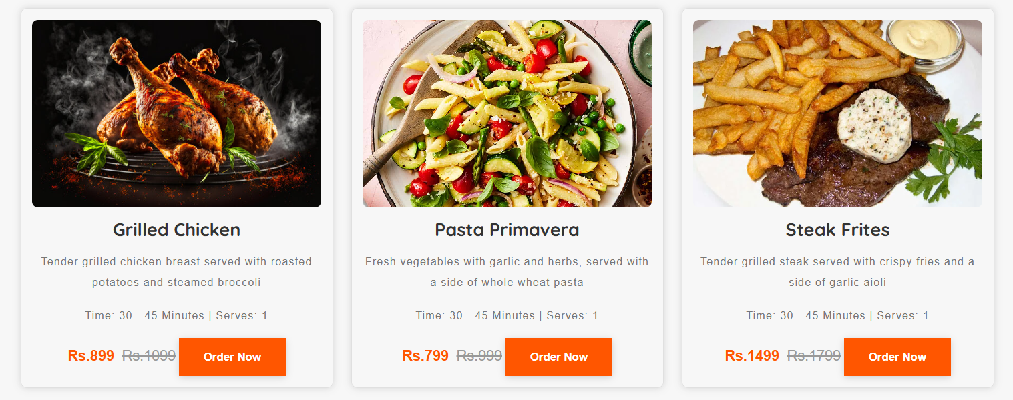

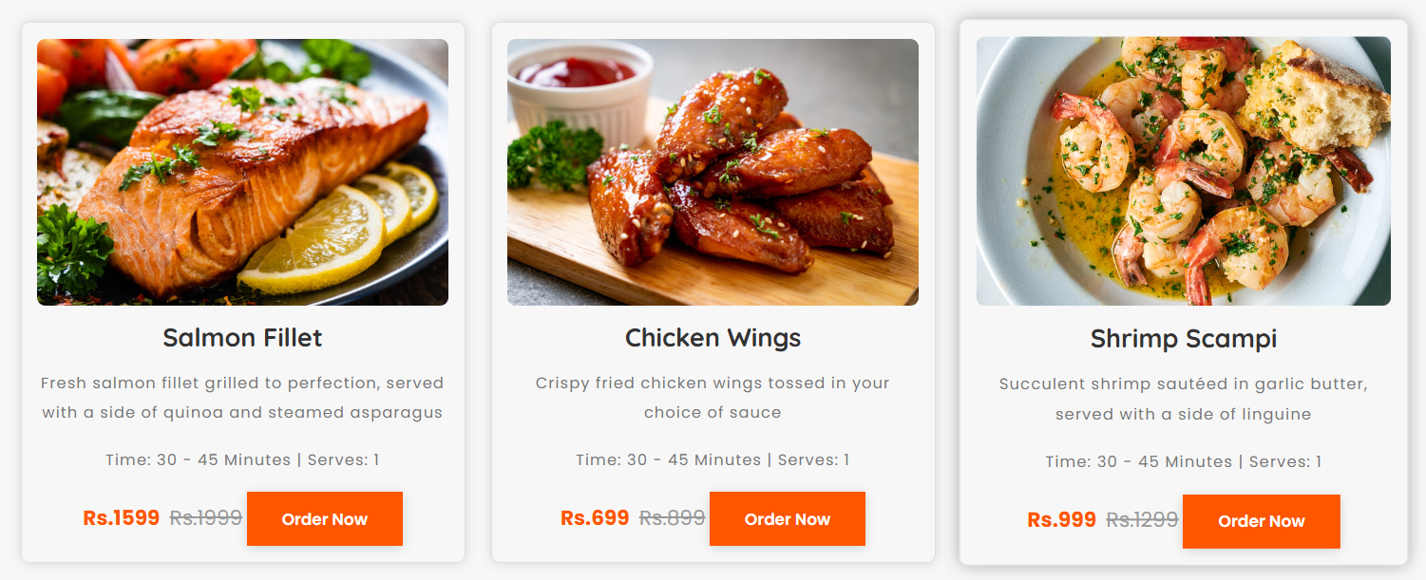

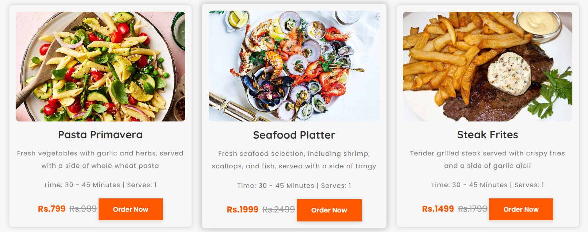

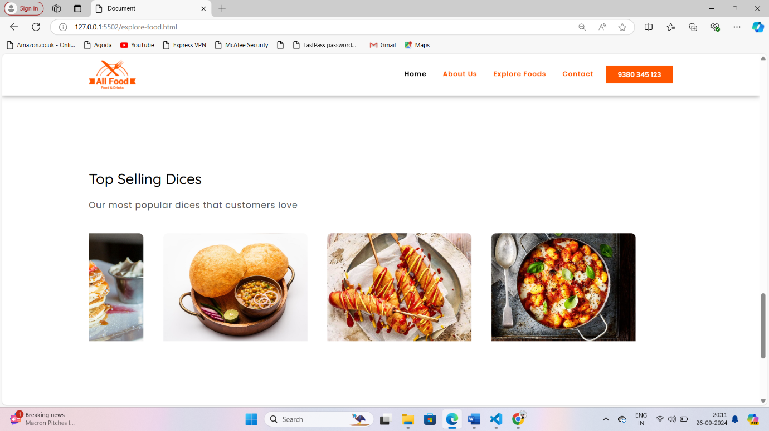



Contact

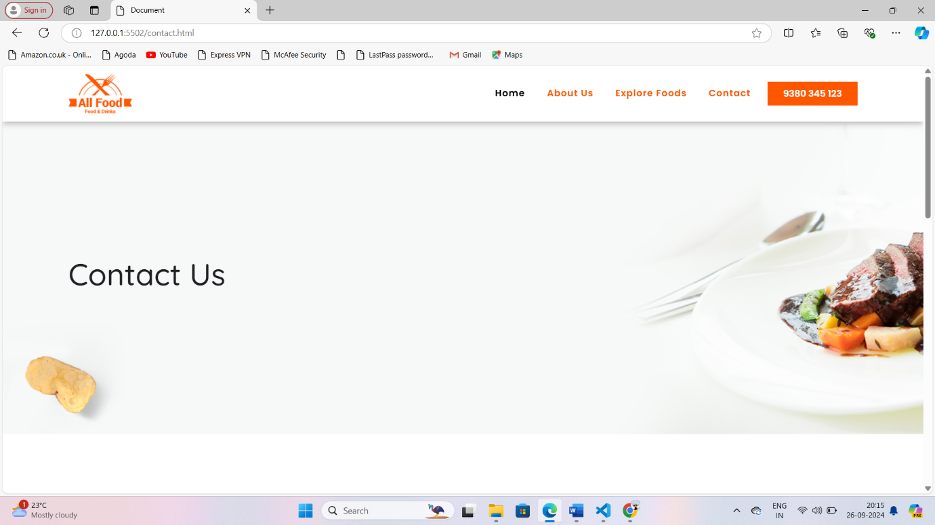

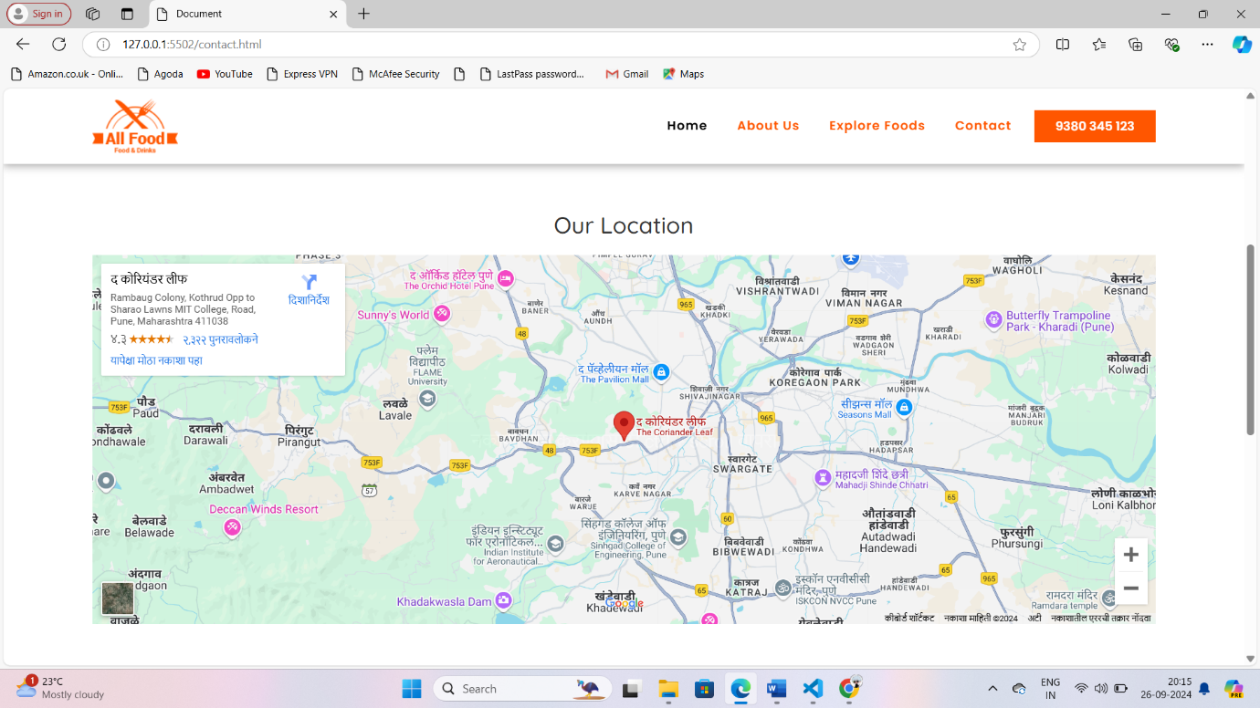

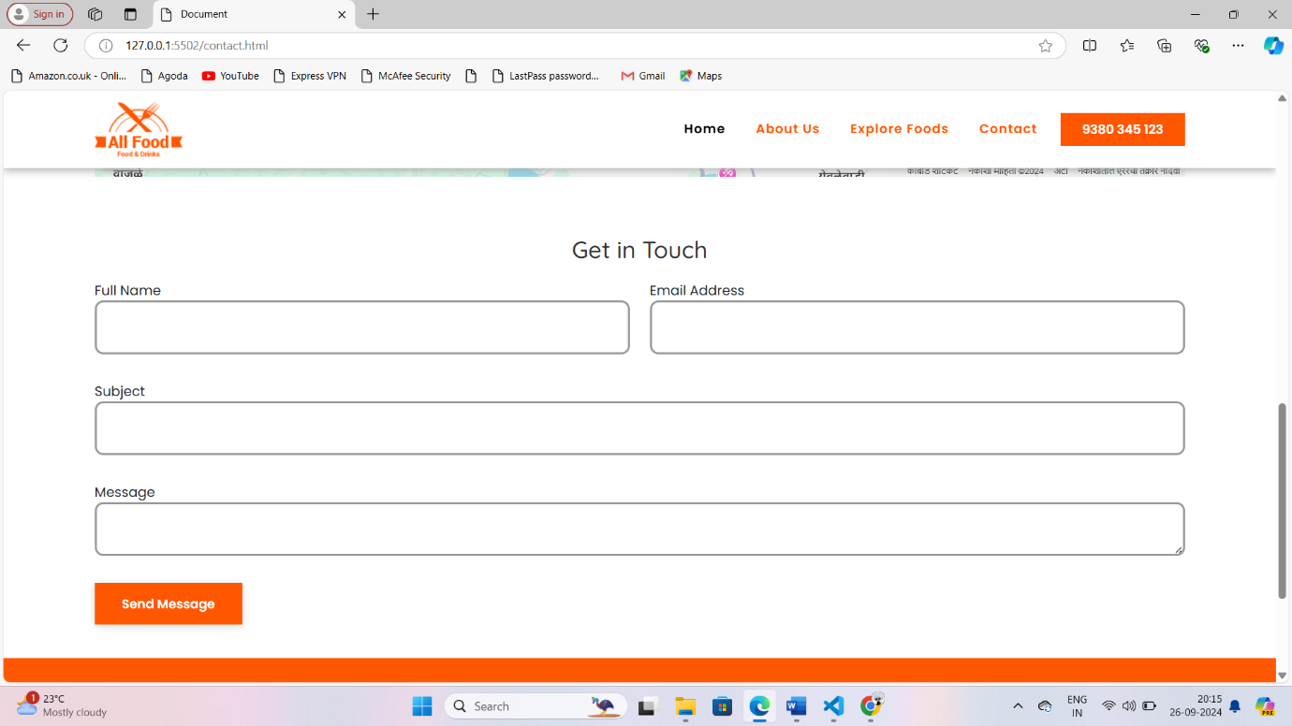



Log in

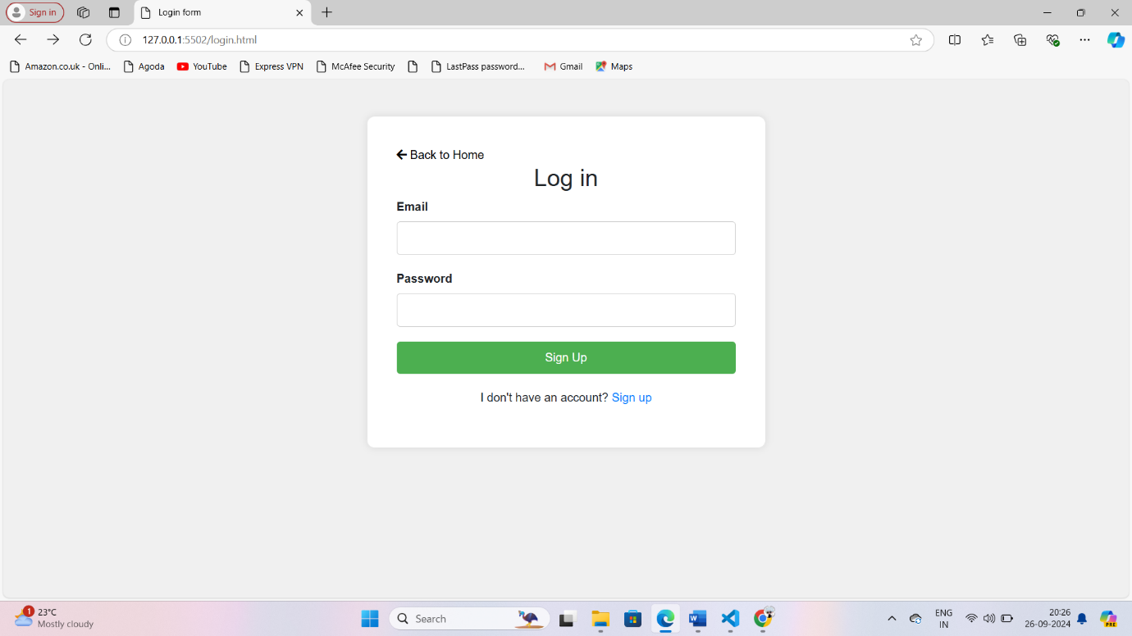

Sign up

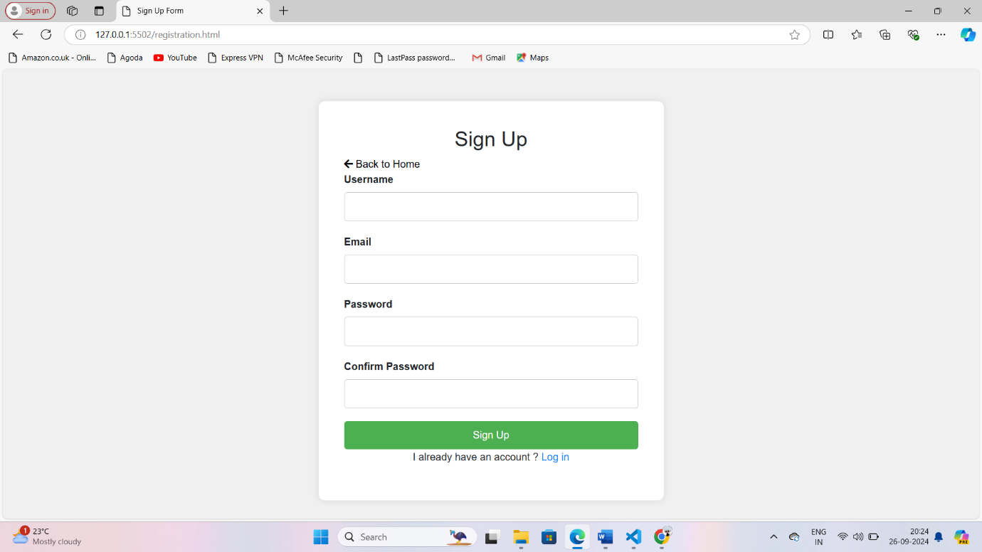

Other Details

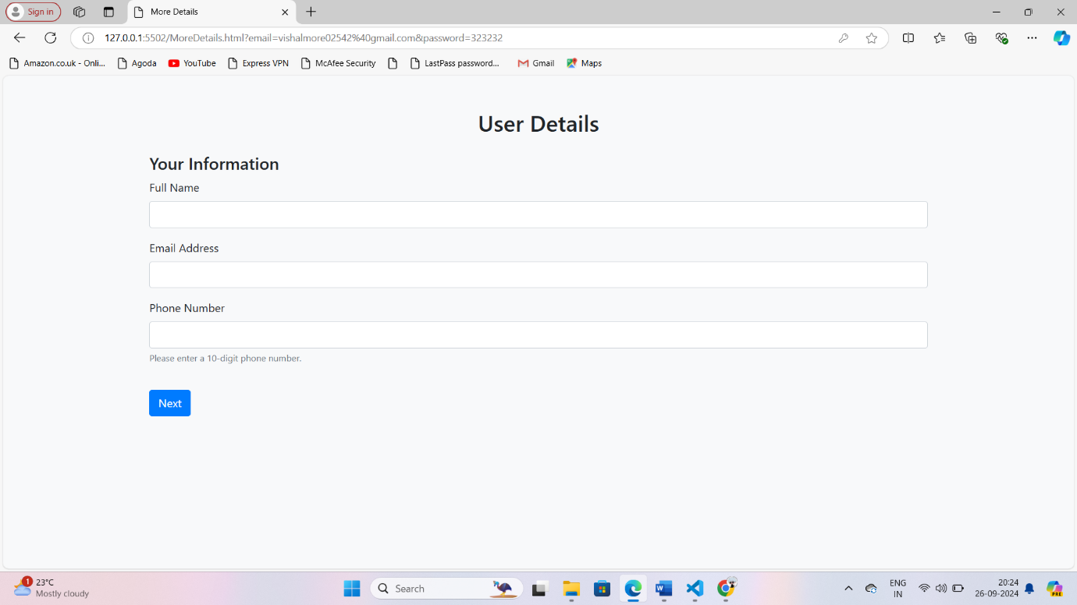

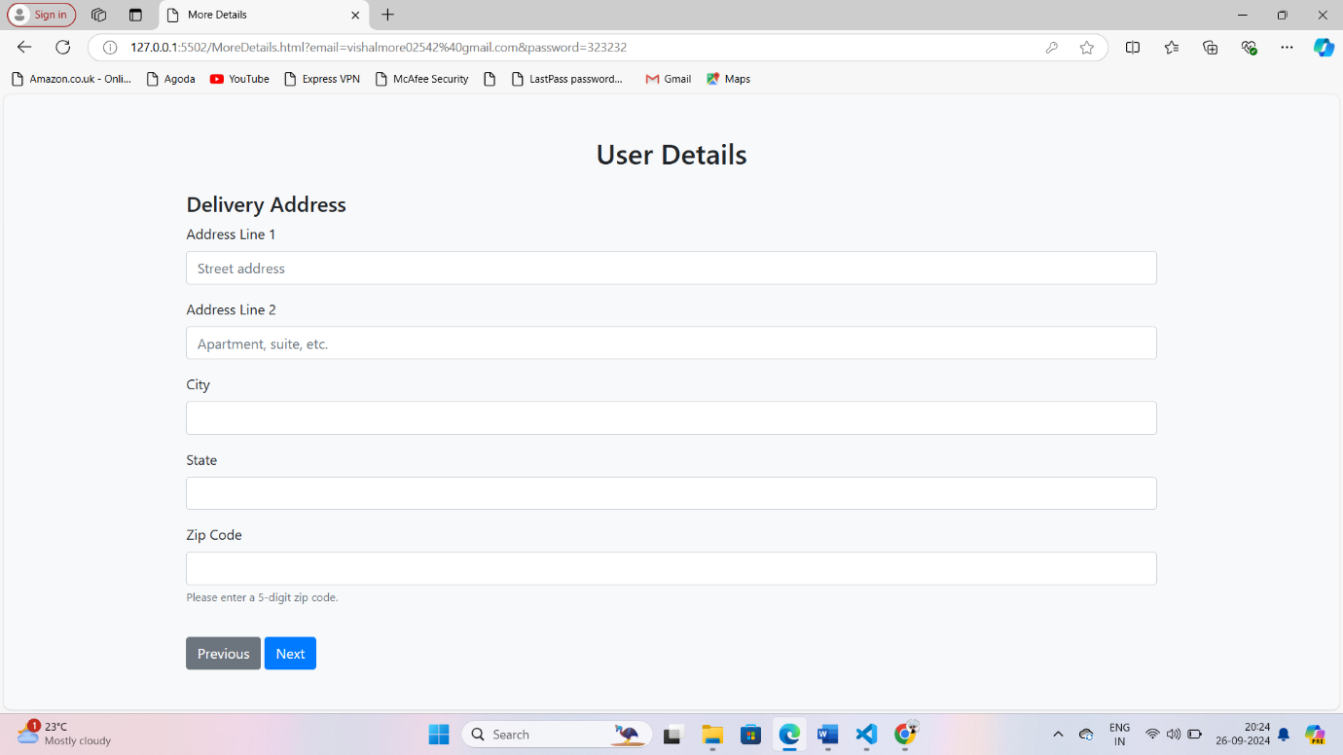

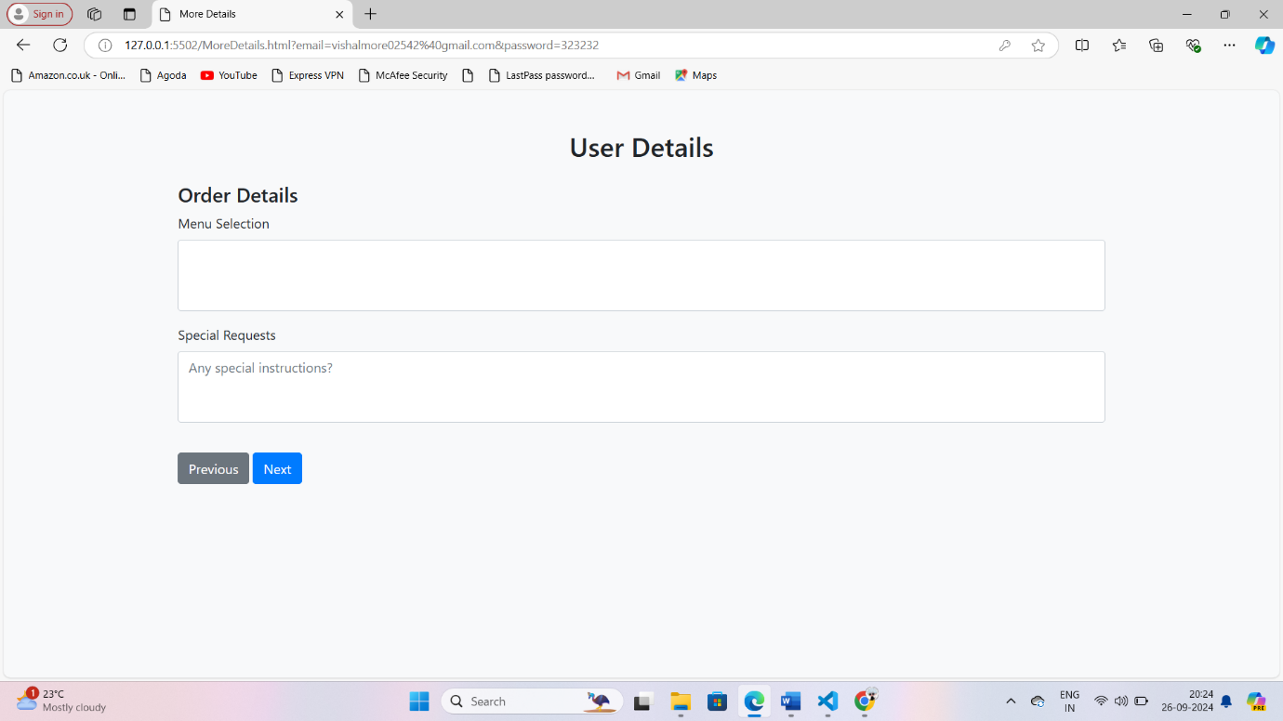

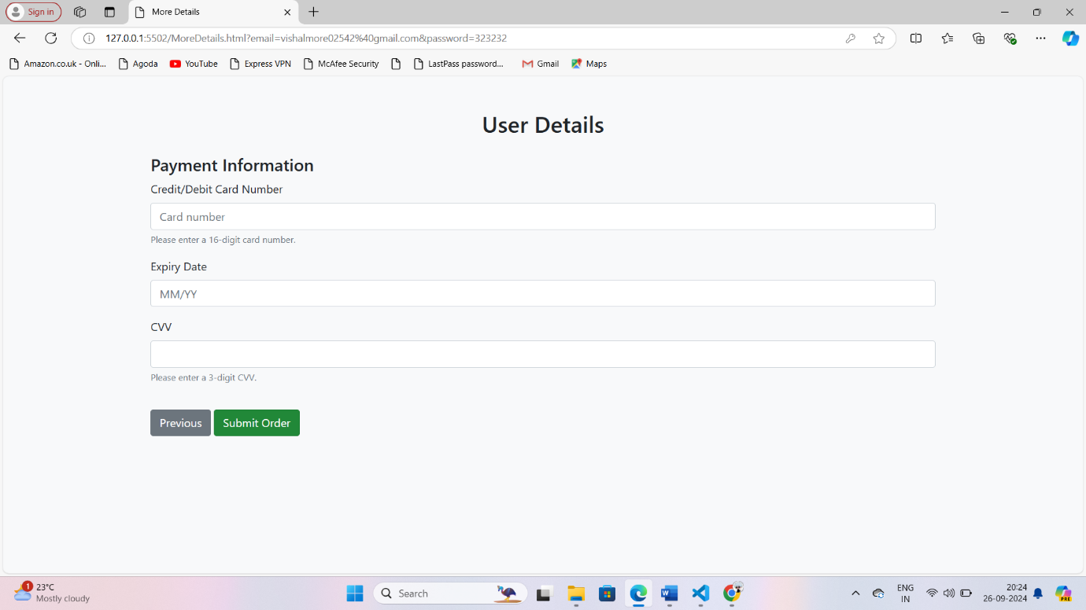

**Thank You...**